A Project Report on
Contact Book Using Python
Submitted in partial fulfilment of a ward of
BACHELOR OF TECHNOLOGY
Degree
In
Computer Science &Engineering Submitted By

ADYANSH BHARDWAJ
2300820100009

Under the guidance of
Mr. Anurag Malik
Ms. Meenakshi Yadav


Department of Computer Science and Engineering
Moradabad Institute of Technology, Moradabad (U.P.)

Session: 2024-25

DECLARATION

I hereby declare that the project work presented in this report entitled “Contact Book Using Python” in partial fulfillment of the requirement for the award of the degree of Bachelor of Technology in Computer Science & Engineering submitted to A.P.J. Abdul Kalam Technical University, Lucknow, is based on my own work carried out at Department of Computer Science & Engineering, Moradabad Institute of Technology, Moradabad. The work contained in the report is original and project work reported in this report has not been submitted by us for award of any other degree or diploma.

Signature:
Name: Adyansh Bhardwaj
Roll No: 2300820100009
Date:26/12/2024
Place: Moradabad

CERTIFICATE

This is to certify that the Project report entitled “Contact Book Using Python” done by Mr. Adyansh Bhardwaj (2300820100009) is an original work carried out by him in Department of Computer Science & Engineering, Moradabad Institute of Technology, Moradabad under my guidance. The matter embodied in this project work has not been submitted earlier for the award of any degree or diploma to the best of my knowledge and belief.

Date:
Mr. Anurag Malik
Ms. Meenakshi Yadav

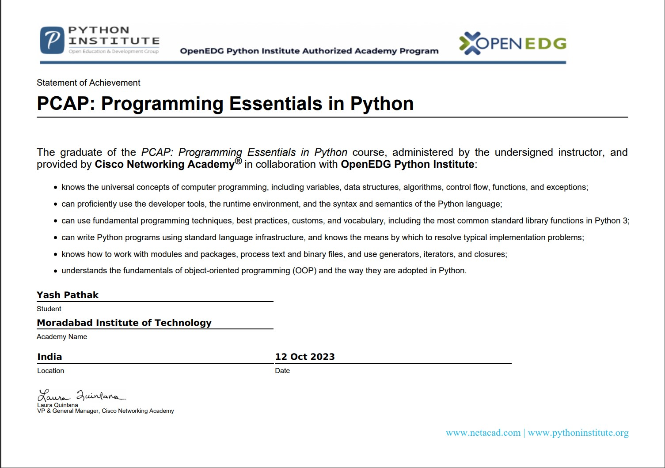

ACKNOWLEDGEMENT

The merciful guidance bestowed to us by the almighty made us stick out this project to a successful end. I humbly pray with sincere heart for his guidance to continue forever.
I pay thanks to our project guide Mr. Anurag Malik and Ms. Meenakshi Yadav who has given guidance and light to us during this project. Their versatile knowledge has cased us in the critical times during the span of this project.
I pay special thanks to our Head of Department Dr. Manish Gupta who has been always present as a support and help us in all possible way during this project.
I also take this opportunity to express our gratitude to all those people who have been directly and indirectly with us during the completion of the project.
I want to thank our friends who have always encouraged us during this project.
At the last but not least thanks to all the faculty of CSE department who provided valuable suggestions during the period of project.

ABSTRACT

Contact books are a useful and widely used kind of application. They’re everywhere. You probably have a contact book on your phone and on your computer. With a contact book, you can store and manage contact information for your family members, friends, coworkers, and so on. Your contact book will provide the minimal required set of features for this kind of application. You’ll be able to display, create, update, and remove the information in your contacts list.
Features of this Contact Book includes:
- Search Contacts
- Remove New Contacts
- Show Contacts Information
- Add or Delete Contact

TABLE OF TABLES

Table 1.1 IDEs of Python……….………………………………………………………………………xv

TABLE OF FIGURES

Figure 1.1 Python logo……………………………………………………………………………….…ix
Figure 1.2 Features of python…………………………………………………………………………x
Figure 1.3 Guido Van Rossum………………………………………………………………………xiv
Figure 4.1 Output1 ……………………………………………………………………………………xxvii Figure 4.2 Output 2……………………………………………………………………………………xxvii

CONTENT
TITLE PAGE………………………………………………………………………………………………………. i
DECLARATION ................................................................................................ ii
CERTIFICATE ................................................................................................. iii
ACKNOWLEDGEMENT .................................................................................... v
ABSTRACT ......................................................................................................vi
TABLE OF TABLES…………………………………………………………………………………………….vi
TABLE OF FIGURES………….………………………………………………………………………………vii
CONTENT………………………………………………………………………………………………………viii
CHAPTER 1 INTRODUCTION ............................................................................ ix
Python..……………………………………………………………………………………………………………………ix
Features of Python………………………………………………………………………………………..............x
Future Technologies Counting on Python………………………………………………………………..xi
History of Python……………………………………………………………………………………………………xiii
CHAPTER 2 IDEs OF PYTHON .......................................................................... xv
Pycharm………………………………………………………………………………………………………………….xvi
Anaconda…………………………………………………………………………………………………..…………..xvi
CHAPTER 3 GRAPHIC USER INTERFACE .........................................................xvii
Tkinter…………………………………………………………………………………………………………………..xvii
CHAPTER 4 PROJECT ..................................................................................... xviii
Introduction………………………………………………………………………………………………………….xviii
Basic Operations…………………………………………………………………………………………………..xviii
Source code……………………………………………………………………………………………………………xx
Output……………………………………………………………………………………………………………… ..xxiii
CHAPTER 5 CONCLUSION ............................................................................. xxiv
CHAPTER 6 BIBLIOGRAPHY ......................................................................... xxvx

CHAPTER 1 INTRODUCTION

1. Python
Python is widely used general-purpose, high level programming language. It was initially designed by Guidovan Rossum in 1991 and developed by Python Software Foundation. It was mainly developed for emphasis on code readability, and its syntax allows programmers to express concepts in fewer lines of code.
Python is a programming language that integrate systems more efficiently.
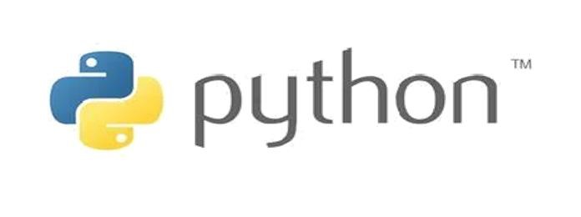
Fig1.1 python logo

Python is a high-level, interpreted, and interactive and object oriented scripting language. Python is designed to be highly readable. It uses English keywords frequently where as other languages use punctuation, and it has fewer syntactical constructions than other languages.
- Python is Interpreted - Python is processed at runtime by the interpreter. You do not need to compile your program before executing it. This is similar to PERL and PHP.
- Python is Interactive – You can actually sit at a Python prompt and interact with the interpreter directly to write your programs.

- Python is Object-Oriented – Python supports Object-Oriented style or techniques of programming that encapsulates code within objects.

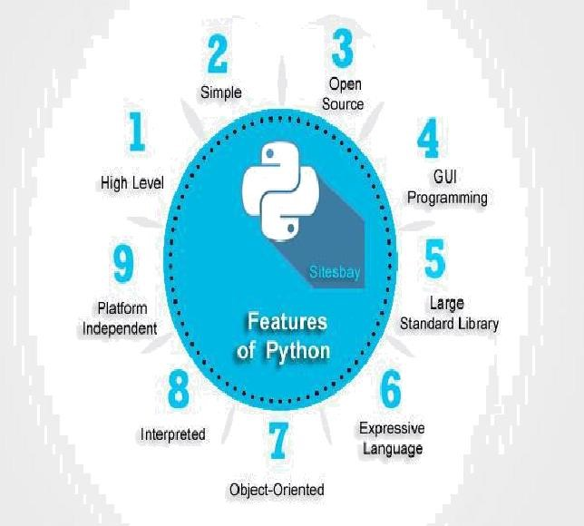

Fig1.2features of python

2. Features of Python

Python's features include −
•Easy-to-learn − Python has few keywords, simple structure, and a clearly defined syntax. This allows the student to pick up the language quickly.
•Easy-to-read − Python code is more clearly defined and visible to the eyes.
•Easy-to-maintain − Python's source code is fairly easy-to-maintain.
•A broad standard library − Python's bulk of the library is very portable and cross- platform compatible on UNIX, Windows, and Macintosh.
•Interactive Mode − Python has support for an interactive mode which allows interactive testing and debugging of snippets of code.
•Portable − Python can run on a wide variety of hardware platforms and has the same interface on all platforms.
•Extendable − You can add low-level modules to the Python interpreter. These modules enable programmers to add to or customize their tools to be more efficient.
•Databases − Python provides interfaces to all major commercial databases.
•GUI Programming − Python supports GUI applications that can be created and ported to many system calls, libraries and windows systems, such as Windows MFC, Macintosh, and the X Window system of Unix.

3. Future Technologies Counting on Python

Python programming language is extensively used for web development, application development, system administration, developing games etc.
But there are some future technologies that are relying on python. As a matter of fact, Python has become the core language as far as the success of these technologies is concerned. The technologies which use python as a core element for research, production and further developments.

a) Artificial Intelligence

Future technologies like Artificial Intelligence (AI) come into the play. There are plenty of python frameworks, libraries, and tools that are specifically developed to direct Artificial Intelligence to reduce human efforts with increased accuracy and efficiency for various development purposes.
It is only the Artificial Intelligence that has made it possible to develop speech recognition system, autonomous cars, interpreting data like images, videos etc. Python libraries and tools used in various Artificial Intelligence branches are-
- Machine Learning- PyML, PyBrain, scikit-learn, MDP Toolkit, Graph Lab Create, MIPy etc.
- General AI- py Datalog, AIMA, Easy AI, Simple AI etc.
- Neural Networks- PyAnn, pyrenn, ffnet, neurolab etc.
- Natural Language & Text Processing- Quepy, NLTK, genism

b) Big Data

The future scope of python programming language can also be predicted by the way it has helped big data technology to grow. Python has been successfully contributing in analyzing a large number of data sets across computer clusters through its high- performance toolkits and libraries.
Python libraries and toolkit is used for Data analyst is and handling other big data issues are-

- Scikit-Learn
- NumPy
- SciPy
- GraphLabCreate
- IPython
- Bokeh

c) Networking

Networking is another field in which python has a brighter scope in the future. Python programming language is used to read, write and configure routers and switches and perform other networking automation tasks in a cost-effective and secure manner.

For these purposes, there are many libraries and tools that are built on the top of the python language. Python libraries and tools especially used by network engineers for network automation are-
- Ansible
- Netmiko
- NAPALM (Network Automation and Programmability Abstraction Layer with Multivendor Support)
- Pyeapi
- Junos PyEZ
- PySNMP
- Paramiko S

4. History of python

Python was developed by Guido van Rossum in the late eighties and early nineties at the National Research Institute for Mathematics and Computer Science in the Netherlands. Python is derived from many other languages, including ABC, Modula-3, C, C++, Algol-68, Smalltalk, and Unix shell and other scripting languages. Python is copyrighted. Like Perl, Python source code is now available under the GNU General Public License (GPL). Python is now maintained by a core development team at the institute, although Guido van Rossum still holds a vital role in directing its progress.

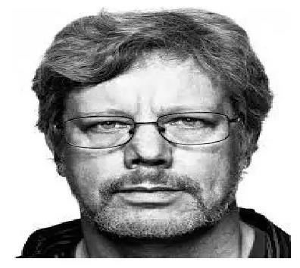
Fig1.3Guido Van Rossum

CHAPTER 2 IDEs OF PYTHON

There are also many IDEs (integrated development environment software) available for Python.
A brief list is as shown below:

Table 1.1 IDEs of Python
IDLE – A GUI based IDE that comes pre-installed with the reference implementation | Open Source | Windows,  OS, Linux | Mac | https://www.python.  org/download/
PyCharm – A GUI based IDE by JetBrains supporting codecompletion, code-  debugging, refactoring etc. | Commercial/F ree  Community  Edition | Windows,  OS, Linux | Mac | https://www.jetbrain  s.com/pycharm/down  load/
Anaconda is a free and open-source distribution of the Python and R programming languages for data science and machine learning related applications that aims to simplify package management and  deployment | Free and  Open Source | Windows,  OS, Linux | Mac | https://www.anacond  a.com/download/

1. PyCharm

PyCharm is an integrated development environment (IDE) used in computer programming, specifically for the Python language. It is developed by the Czech company JetBrains. PyCharm Community Edition is free and open-source, available under the Apache 2.0 license.
PyCharm makes it easier for programmers to write various web applications in Python supporting widely used web technologies like HTML, CSS, JavaScript, TypeScript, and Coffee Script.
PyCharm is available in three editions: Professional, Community, and Educational (Edu). The Community and Edu editions are open-source projects, and they are free, but they have less features. PyCharm Edu provides courses and helps you learn programming with Python.

2. Anaconda

Anaconda is a free and open-source distribution of the programming languages Python and R (check out these Python online courses and R programming courses). The distribution comes with the Python interpreter and various packages related to machine learning and data science. The idea behind Anaconda is to make it easy for people interested in those fields to install all (or most) of the packages needed with a single installation

CHAPTER 3 GRAPHIC USER INTERFACE

GUI stands for Graphical User Interface, and refers to computer programs that provide a visual means for users to interact with an underlying application or system. For example, the GUIs on our mobile phones allow us to interact with different functions through the display, which we can touch, tap, and swipe on. In this article, we’re looking at exactly what Python GUI Programming is, why it is useful, and how you can get started with building one of your own!

1. Tkinter

The tkinter package (“Tk interface”) is the standard Python interface to the Tcl/Tk GUI toolkit. Both Tk and tkinter are available on most Unix platforms, including macOS, as well as on Windows systems.
Running python -m tkinter from the command line should open a window demonstrating a simple Tk interface, letting you know that tkinter is properly installed on your system, and also showing what version of Tcl/Tk is installed, so you can read the Tcl/Tk documentation specific to that version.
Tkinter supports a range of Tcl/Tk versions, built either with or without thread support. The official Python binary release bundles Tcl/Tk 8.6 threaded. See the source code for the _tkinter module for more information about supported versions.
Tkinter is not a thin wrapper, but adds a fair amount of its own logic to make the experience more pythonic.

CHAPTER 4 PROJECT

1. Introduction

The purpose of this report is to document the development of a contact book using Python. The contact book is designed to help users to search, remove, display, and add a new contact information. The project was developed in Python programming language using Object-Oriented Programming (OOP) concepts.
The primary objective of the project is to develop a contact book using Python that can perform the following tasks:
- Add a new contact information
- Display all the contacts in the contact book
- Search for a specific contact
- Remove a contact from the contact book
Secondary objectives of the project include:
- Creating a user-friendly interface
- Implementing error handling mechanisms to avoid runtime errors
- Using Object-Oriented Programming (OOP) concepts to create the contact book
- Creating a robust code structure that can be easily extended for future enhancements
The contact book project was developed using Python programming language and Object-Oriented Programming (OOP) concepts. The project was divided into the following modules:
- User Interface
- Contact Manager
- Contact
The User Interface module is responsible for creating the graphical user interface (GUI) of the contact book. The module uses the Tkinter library to create the GUI.

2. Basic Operations

Search: By Entering choice 1. We can search Contact from the stored contacts on the contact book.
Remove: By Entering choice 2. We can remove Contact from the stored contacts on the contact book.
Display: By Entering choice 3. We can view Contact from the stored contacts on the contact book.
Add: By Entering choice 4. We can add new Contact in the stored contacts on the contact book.
Exit: By Entering choice 5. We can exit the contact book

3. Source Code
L

4. OUTPUT

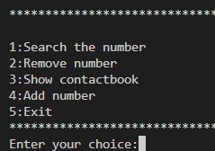

Fig4.1Output 1
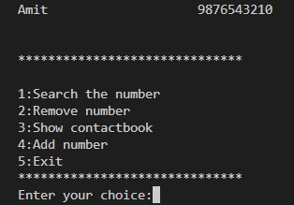
Fig4.2 Output 2

CHAPTER 5 CONCLUSION

Building a Contact Book GUI application with Python, PyQt, and SQLite is an excellent exercise for you to expand your skills with these tools and as a developer in general. Coding projects like this allows you to apply the knowledge and skills you already have and also pushes you to research and learn about new topics every time you encounter a new programming problem.

CHAPTER 6
BIBLIOGRAPHY

- Python Software Foundation. (2021). Python 3.10.0 documentation. Retrieved from https://docs.python.org/3/

- Tkinter GUI Application Development Blueprints: Master GUI programming in Tkinter as you design, implement, and deliver ten real-world applications. (2018). Packt Publishing.

- Python GUI Programming with Tkinter. (2021). Retrieved from https://www.tutorialspoint.com/python/python_gui_programming.
htm

- Python GUI Programming with Tkinter. (2021). Retrieved from https://www.geeksforgeeks.org/scientific-gui-calculator-usingtkinter-in-python/

